African Great Lakes Peace Trust
Oct 2016 to Sept 2017
Our funding assists both vocational support for young people and peace building. Huge numbers of unemployed young people are at great risk in this region of Africa, where there is great need for alternatives to the attractions of illegal activity and terrorism. Your donation can do something constructive to reduce terrorism, especially as we have a specific fund for work in the refugee camps.
We supported Transforming Communities for Social Change (TCSC) in holding Alternatives to Violence Project (AVP) workshops in the huge Kakuma complex of refugee camps in North-western Kenya. There are two main camps, housing a total of 185,000 people from many nations and social groups. The conflicts that drove them from their homes are difficult to leave behind and the camps are violent places.
“Participants understand well when the training is participatory rather than lecture. Non-violent conflict resolution is a skill. It improves with practice and optimistic persistence.
After successfully training 112 participants - 42 Congolese, 37 South Sudanese, 21 Burundians, 2 Ugandans, 6 Ethiopians and 4 Somali —participants have volunteered to share the skills in their small communities in the camp. As they take their conflict resolution skills with them to implement in their home communities, there is still a need of doing more basic workshop in the camp. We were forced to turn away participants who wanted to join the training because of the overwhelming numbers.” (Peter Serete, Program Manager)
https://transformingcommunityforsocialchange.wordpress.com

We have supported our Rwandan friend Rachel Bugenimana in her work with a small team helping young drug abusers both within and just outside the Kigeme camp in south-western Rwanda. This camp houses refugees mostly from the south Kivu region of Congo (DRC). These people have little realistic hope of returning home in the near future, but no legal status in Rwanda either. Maintaining hope and a sense of purpose is an uphill struggle, especially when most have fled appalling violence in their homes.
The first step is to get the camp clean of drugs. The young people then need worthwhile activity and help with re-integration into their community. Rachel reports a reduction in violence and crime in the camp and includes testimonies from young people on the project:
Participants 1 says (boy): After these two levels of AVP Training, I learn that my family violated me but I have violated myself, I decide to never again selling drugs in camp and I will start looking for another thing to do.
Bududa learning Centre teaches vocational skills to striving young adults, provides social services to orphaned children and finances poor working women in their micro businesses. Living on the slopes of Mount Elgon, in one of the poorest, most remote and most beautiful areas of Uganda, the peasants of Bududa beckon us and you to be citizens of the world by helping them.

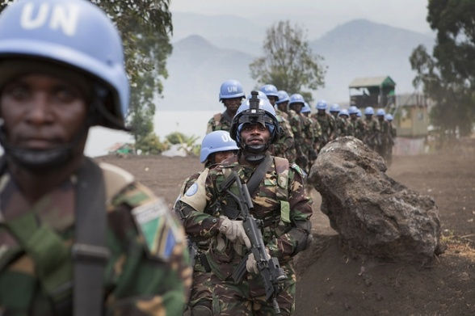
We have also contributed to the work of the Quaker Congo Partnership (QCP) in their peace building workshops and training in South Kivu, Democratic Republic of Congo. QCP have run Alternatives to Violence (AVP) workshops for people of the Middle and High Plateaux Region of South Kivu. There are many social groups represented here, with historic rivalry and enmity to overcome. The region suffers “resource blight” being home to deposits of valuable minerals useful to Western industry. The struggle to control the very profitable extraction of these minerals fuels constant conflict in the area.
Two of our Trustees have visited the Great Lakes region in the past few months and we hope that others will be able to go during 2018. While we receive reports and evaluation from project leaders, it is useful to see the work at first hand. Our partners appreciate the support offered by such visits.
As Trustees, we continue to raise both funds and awareness of the peace building work of our partners in the Great Lakes Region of Africa. We especially seek supporters willing to commit to long-term contribution to this essential work. We are always ready to talk to interested groups.
African Great Lakes Peace Trust Trustees: Elizabeth Cave, Ann Floyd, Phil Hellen, Margot Lunnon, Dorothy Nelson, Andrew Rendle.
February 2018
African Great Lakes Peace Trust
We are a UK-based charity supporting peace-building work in Burundi, DRC, Kenya, Rwanda, Tanzania and Uganda. We make grants for peace-building initiatives and for travel in support of them, working closely with our partners in the Great Lakes region.
All our funding comes from donations, and contributions to support this work are very welcome.
You can donate online at www.aglpt.org.uk, or send to
AGLPT Treasurer, 17 Front Street, Wearhead via Crook, DL13 1BL UK. 07766 758 405
Name:
Address:
Postcode
□ I am a UK taxpayer and would like AGLPT to claim gift aid on this donation/this and all future donations (delete as appropriate)
Date:

Signature:
African Great Lakes Peace Trust, Charity Commission reg 1154597
You may like to hear more. Contact us to arrange a speaker.
www.africangreatlakespeacetrust.org.uk

