African Great Lakes
Peace Trust
Annual Report
1 October 2017 – 30 September 2018

Introduction
AGLaPT exists to promote conflict resolution and reconciliation in the African Great Lakes region (Rwanda, Burundi, DRC, Kenya, Uganda). It does this by supporting projects which work within communities suffering violence to help identify the causes of conflict, find solutions, and provide support for those affected by conflict.

In 2017 – 2018 we have maintained our policy of making grants to local peace building initiatives and programmes to help refugees in the countries around the Great Lakes. We have made grants totalling £28,697 to projects in Rwanda, Democratic Republic of Congo, Kenya and Uganda. Our greatest challenge is to maintain our income to meet our commitment to these organisations. There are always more worthy projects than we can afford to support so any donations or fund-raising initiatives would be more than welcome.

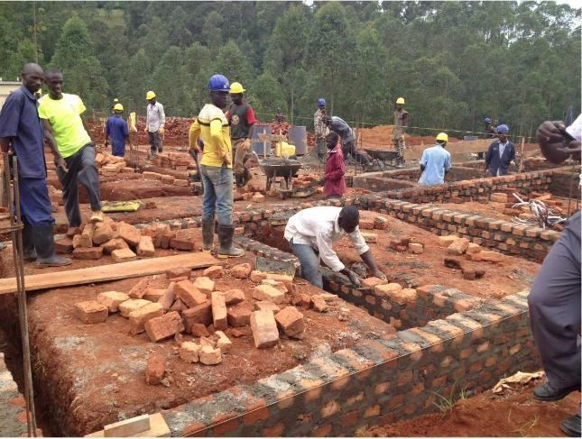

Bududa Learning Center teaches vocational skills to striving young adults, provides social services to orphaned children, and finances poor working women in their micro businesses. Living on the slopes of Mount Elgon in one of the poorest, most remote, and most beautiful areas of Uganda, the peasants of Bududa will need our support for some time to come.
Thanks to a substantial legacy, we were able to help Bududa Learning Centre to install a solar power system for their vocational programmes, powering computers, sewing machines and hairdryers.
The picture shows students on the masonry course.
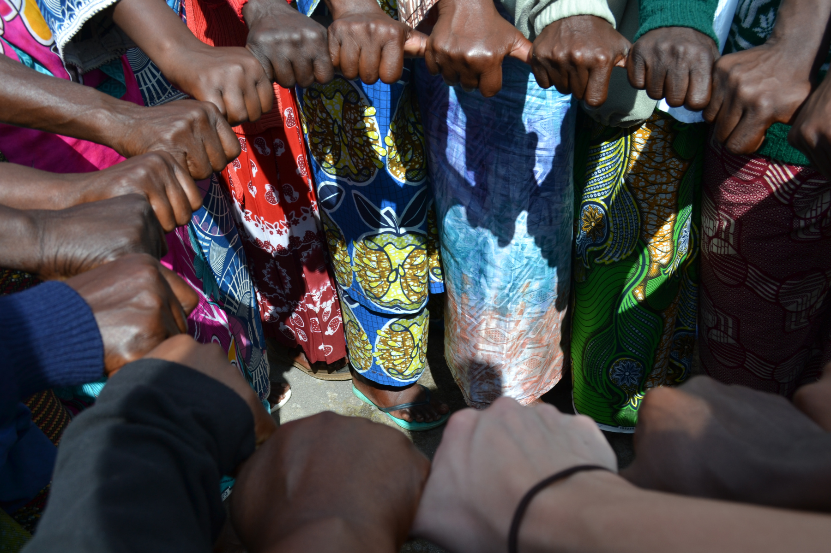
HEALING AND REBUILDING OUR COMMUNITIES

We have given money to support Healing and Rebuilding Our Communities workshops in Uganda for urban refugees from South Sudan, Rwanda, Congo and Burundi. We have received detailed reports from the facilitating organisation PREMMAC and will continue to support as they follow up their initial work.
“I was sad but when I heard the pain that other people shared I realized that my pain was less than others. And I was always having recurring dreams about my relatives that passed on but after the training those dreams stopped. I also learnt that it’s better to remove all the pain I have in my heart.” (HROC Participant)

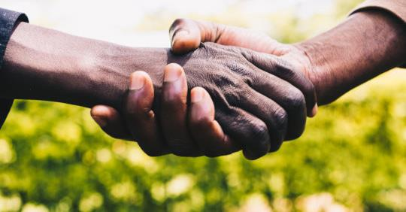
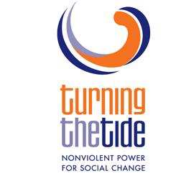 in Kenya

We have supported Turning the Tide Kenya in nonviolent campaigns in four separate areas, working on local issues of injustice affecting the community. We have also helped with an exchange programme so that different areas can learn from each other’s successes. We monitor the group’s evaluation and plans for improvement.
For more information go to
www.quaker.org.uk/blog/turning-the-tide-a-year-of-nonviolent-campaigning-in-east-africa

Ministries of Hope Rwanda
We have contributed to the programme’s work in refugee camps in the south west of Rwanda, providing work opportunities and peace building training for young people. Young men have told peace workers they want to get out of using and selling drugs, into more constructive activities. It is hard for so many reasons from gang pressure to restrictions placed on refugees who want to work.

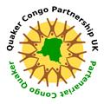

QUAKER CONGO PARTNERSHIP

The Centre for Education, Peace and Psychological support (CEPAP) is supported by Quaker Congo Partnership. There are several varying strands to this project: school fees for 40 vulnerable children, sport, music, drama activities and exchanges with young people, vocational training for school graduates, a programme to prevent sexual violence, peacebuilding and conflict resolution workshops and one to one counselling. The African Great Lakes Peace Trust (AGLPT) has helped fund peacebuilding workshops in the high plateau where militia have been active and there have been attacks recently, houses burnt and many displaced people and refugees. This peace building activity is all the more crucial in light of forthcoming elections.
HELP INCREASE THE PEACE PROJECT
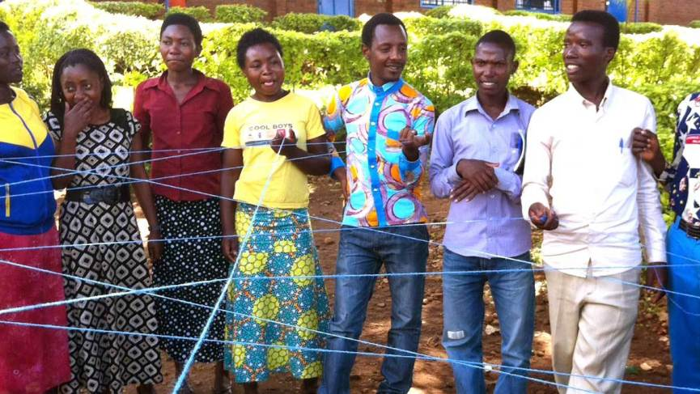
We have given money to support the work of HIPP Programme (Help Increase the Peace Programme) organized by Rwanda Yearly Meeting of the Society of Friends. This work concentrates on young people who did not experience the genocide but whose lives have been tainted by it.
“The work offered Help Increase the Peace Program (HIPP) workshops for Rwanda youth in Friends churches, ages 14-24. This project included workshops for potential leaders in all four Rwandan quarterly (regional) meetings. HIPP Trainers go to each of the four regions to conduct the trainings. Those trained this year will form an initial group of trainers who will then offer workshops in their own local meetings in the future.”
From Rwanda Yearly meeting proposal document 2017

African Great Lakes Peace Trust
We are a UK-based charity supporting peacebuilding work in Burundi, DRC, Kenya, Rwanda, Tanzania and Uganda.
We make grants for peacebuilding initiatives and for travel in support of them, working closely with our partners in the Great Lakes region.
All our funding comes from donations, and contributions to support this work are very welcome.
You can donate online at www.aglpt.org.uk, or send to
AGLPT Treasurer, 17 Front Street, Wearhead via Crook, DL13 1BL UK.

Name:

Address:

Postcode
□ I am a UK taxpayer and would like AGLPT to claim gift aid on this donation/this and all future donations (delete as appropriate)
Date:
Signature:
Your organisation may like to hear more. Contact us to arrange a speaker.
www.africangreatlakespeacetrust.org.uk African Great Lakes Peace Trust, Charity Commission reg 1154597

