Trying to understand about Refugees in East Africa  Our tiny charity has funded workshops for refugees in Kakuma refugee camp, in Kenya but near the western border with South Sudan and with Uganda. The workshops have been in Healing and Rebuilding our Communities (HROC) or AVP, Alternatives to Violence Project. Both are meant to strengthen participants’ skills and determination not to let any conflict or hostility get worse. People in the camps are so anxious and frustrated it is hardly surprising if they lose patience with one another.  We have money in principle to fund more such workshops but it can help both trustees and workshop participants if a Trustee goes to have a look—though she will be overwhelmingly aware of her own ignorance. |  |  |  | 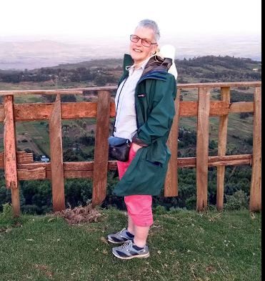
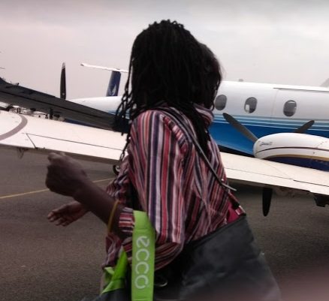 | Getting to Kakuma was quite a performance:  - Fly from Nairobi to Eldoret and pick up a facilitator who had led the workshops in Kakuma  - Fly from Eldoret to Lodwar and look for a taxi willing to take us 3 hours/ 75 miles over a dirt road to Kakuma  - Spend the night in a UNHCR compound  - Go on by taxi to Kakuma II  - Spend two hours talking with refugees in various languages  - 3 hours on the same dirt road back and a night in Lodwar  - Fly back to Nairobi  The facilitator, Peter Serete, would normally go from his home to Lodwar by bus which would take even longer. When I visited there was no –one in Kakuma trained to lead a workshop himself or herself. The supply chain is long, and participants do not usually know when they will be able to go on to the next stage of training. They are desperate also for vocational training although they are supposed not to work outside the camp. There is plenty for us to do; and both in Kenya and Uganda refugees are numbered in the near millions.
One thing I did know before going to Kakuma was that Refugee Camps are not usually temporary. People tend to live in them for a very long time: they may have children and even grandchildren while they are there. Another thing I dimly knew is that refugees move about. They may go home, though the great majority will not do so. A few people will develop links with rich countries and move to them. Refugees may move from one camp to another. Hence camps are not totally prison-like. At Kakuma there are two camps, one is older than the other and has a shopping street. 16 miles from Kakuma is another settlement called Kalobeyei where Kenya is trying a variant of the Uganda approach to refugees: don’t put them in camps, give them smaller allowances, but give them a bit of land and allow them to trade and move about. –-I know from Citizens Advice work in this country that no bureaucracy works as it was meant to; where there is poverty and corruption this is much more likely to be the case. The supposed rules exist only to be broken. Besides the refugees who are accepted as such there may be the same number again who are illegals: and no refugee is popular with the locals. |  |  | 